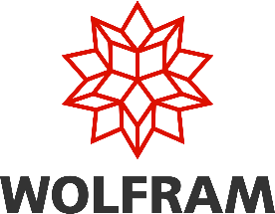

BENEFITS OF WOLFRAM MATHEMATICA 14.3

We are pleased to announce Mathematica Version 14.3 is launched and it’s a big release, with lots of important new and updated functionality, particularly in core areas of the system.

It introduces 115 new functions, that significantly expand capabilities across a wide range of domains and adds full support for dark mode. Improvements in Data, visualization, geometry, machine learning, AI, algebra, calculus, special functions, video, system modelling, control systems, PDEs, chemistry and compiler improvements.

Please find the Version 14.3 highlights below –

- Version 14.3 adds full support for dark mode and introduces new standard colors designed for both dark- and light-mode environments.
- It completes the implementation of noncommutative algebra (started in Version 1.0) and adds Hilbert transforms, Lommel functions and new matrix decompositions.
- Visualization capabilities expand with ListFitPlot for automatic curve fitting, surface plotting functions, vector-based maps and mesh processing tools.
- Other key additions include geodesic computation, LLMGraph for AI workflow orchestration, significantly faster Python and R integration, ColumnwiseCombine for tabular data operations, system model validation tools and Markdown export support.

Please find all new features and functionality in Mathematica v14.3 here: https://www.wolfram.com/mathematica/quick-revision-history/
Please let us know your thoughts and contact us for getting access to Mathematica 14.3

Contact details:
  - Pradeep R
Mob : +91 9845016309
E-mail ID : pradeep@gte-india.com

  - Vinaya Kumar M C Mob : +91 9611437000
E-mail ID : vinayakumar@gte-india.com

For more information visit:
  - https://www.wolfram.com/mathematica/
  - https://gte-india.com/

